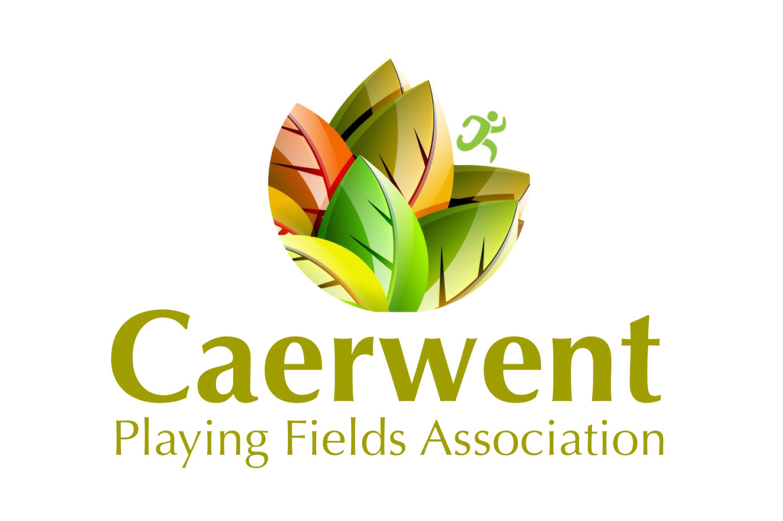
Advertising Agreement Form for Caerwent Community Magazine

Caerwent Playing Fields Association
c/o 2 Cwrt Morgan
Caerwent
Caldicot
Monmouthshire. NP26 5QZ
Advertiser Name
Business Address
Phone Number
Email
Authorized Person
(If not as above)
Agreed Start Date |  | Agreed End date

The above Advertiser agrees to advertise in the Caerwent Community Magazine according to these listed advertising opportunities. Please fill in the following information:

Advertising Space | Cost | Chosen Option (please tick)
Full Page A4 (1 Edition) | £50
Half Page (1 Edition) | £25
Half Page (6 Editions) | £140
Half Page (11 Editions) | £250
Quarter Page (1 Edition) | £15
Quarter Page (6 Editions) | £80
Quarter Page (11 Editions) | £150

Signature of Advertiser /or Authorized Person | Date
I agree to be bound by the Terms and Conditions described overleaf

Signed on behalf of Caerwent Playing Fields Association | Date

Terms & Conditions of Sale of Advertising Space

- This agreement is between Caerwent Playing Fields Association Ltd (CPFA) and the Advertiser listed overleaf

- Both parties will mutually agree upon the start and end date, which will be the basis of the term of this agreement.

- The Advertiser assumes all risk for content and agrees to indemnify the CPFA against liabilities and claims of any kind and damages which arise from the advertisement and any consequential marketing and or promotions.

- Adverts are placed within the publication at the absolute discretion of the Editor who’s decision shall be final

- Advertisers can either supply their own artwork or CPFA can produce artwork at a charge to be agreed between the parties.

- Artwork produced for the Advertiser by the CPFA will remain in the ownership of the CPFA unless agreed otherwise.

- Any artwork produced will be approved by the Advertiser before use at least 7 working days prior to publication.

- Supplied artwork should comply with the following size limitations and be supplied electronically by email to newsletter@caerwentplayingfields.com

Full Page A4 - 200 x 280 mm
Half Page A4 - 200 x 140 mm
Quarter Page - 200 x 70 mm or 100 x 140 mm

- All advertisements must be approved by CPFA prior to going live.

- Adverts or amendments should be submitted to the Editor by 15th of the month before required publication. In the case of long-term adverts any amendments during the duration of the agreed advertising period should adhere to the same submission time scales.

- Payment is due 10 days before the advert goes live. Single entry adverts cannot be cancelled. Longer adverts need to be paid for in advance as per the advertising rates overleaf. Cancellation of multiple months before expiration of contract will result in a cancellation fee equal to that of the cost of space for one month.

- The Advertiser shall retain all rights, title and interest in, including copyright and other intellectual property rights, with respect to any copy, photograph or advertisement published.

- The Advertiser shall not make any statement or representation, whether on its own website or that of the Advertiser or otherwise, to the effect the parties are in a contractual relationship, other than for the purpose of this Agreement.

- Adverts submitted to the CPFA must not contain any content that is unlawful, libelous, defamatory, obscene, abusive, and offensive or otherwise violates any law or right of any third party.

- Advertiser warrants that neither the advertisements nor any statements referred to do not infringe or violate any applicable law, regulation or any statutory instrument applicable in the jurisdiction of England and Wales, do not infringe in any manner any copyright, patent, trade mark, trade secret or other intellectual property right of any third party, do not breach any duty towards or rights of any person or entity and have not otherwise resulted in any consumer fraud, product liability, tort, breach of contract, injury, damage or harm of any kind to any person or entity, are not false, misleading or fraudulent and do not libel, defame, cause injury to, invade the privacy of, harass or otherwise infringe or violate the rights of any person or third party.

- Confirmation and Approval of the advertising agreement and cost will be made via an invoice and email confirmation to listed email address overleaf.

